TCP PLAN AMENDMENT

Existing Plan –

FOR GROUP 1:

- Owners vacate grandfathered mineral extraction zoning status & deed restrict from mineral extraction activities.
- Place a permanent agricultural or conservation easement on 35 acres for every bonus split with Town as an easement holder.
FOR GROUP 2:
- Place a permanent agricultural or conservation easement on 35 acres for every Super Send Area Bonus with Town as an easement holder or sell property to a public governmental entity or non-for-profit for conservation/preservation with Town as a conservation easement owner.

A limited public easement for connecting to other public lands, an ice age trail connection or a multi-use regional trail connection would not be prohibited for either group of properties.

Any unused or Super Sending Area Bonus rights are available for transfer within the town but not within the Super Sending Areas.

FOR GROUP 1: For each unused development right transferred from a TDR-S zoned property in a Group 1 Sending Area, landowners may create up to four (4) development sites in an appropriate receiving area in the TDR-R district or on the TDR-S property with the unused development entitlement.

For GROUP 2:
- For each unused development right transferred from a TDR-S zoned property in a Group 2 Sending Area, landowners may create up to two (2) development sites in an appropriate receiving area in the TDR-R district.
- For properties that have exhausted their development rights prior to 2017 and are within a Group 2 Sending Area, one additional development right will be granted. For each such additional right transferred from a TDR-S zoned property, landowners may create up to one (1) development site in an appropriate receiving area in the TDR-R district.

Recent Plan Update

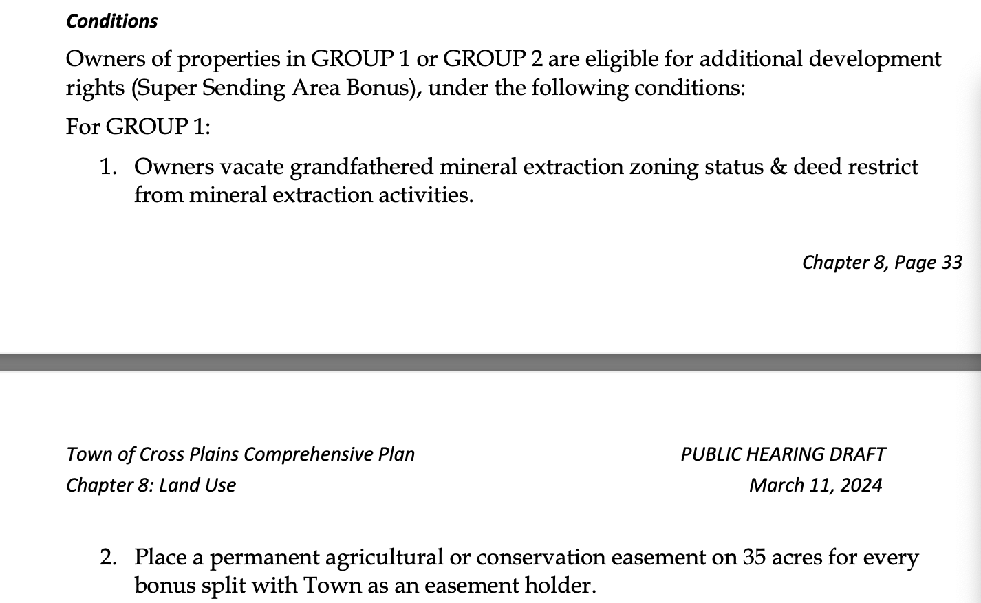
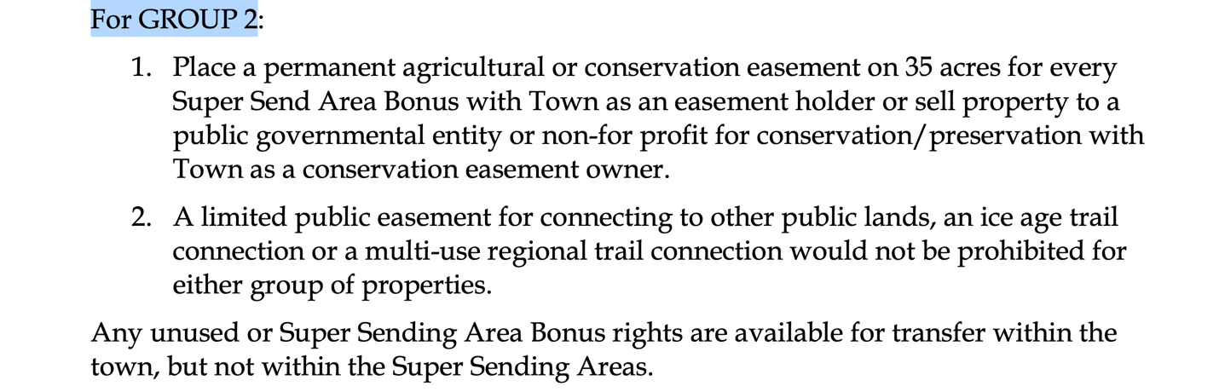

NEW AMENDMENT1 to AMENDED PLAN:

Add the following under the Group 1 conditions:
Any unused or Super Sending Area Bonus rights are available for transfer to an appropriate receiving area in the TDR-R district or on the TDR-S property with the unused development entitlement.

